**Visualizing Brain Activity: Focusing on Where and How Much**

Michael Truong

217892159

York University

PSYC6135

Dr. Michael Friendly

**Abstract**

This paper focuses on the problem of visualizing functional magnetic resonance imaging (fMRI) data in simple scenarios where the activation patterns are of primary interest. I focus on two issues, the “where” and the “how much” of activation. The paper begins with an illustration of the problem; followed by a 3D/4D proposal to address these issues; and concludes with a discussion of an empirical study to test the proposal’s efficacy. The main problems found are that typical 2D visualization make it difficult to understand where a volume of activation is situated; and that they only represent the end result of complex statistical techniques, not the uncertainty and individual data points common to other visualizations. The solution focuses on the use of opacity, multiple perspectives, animation, interactivity, shareability and reproducibility. The empirical study tests the efficacy by comparing region of activation identification accuracy with the different visualizations present and with a delay. It also features a participant interview of their phenomenology of the different visualizations to identify barriers to adoption of the technology.

*Keywords*: 3D visualization, 4D visualization, fMRI

**Visualizing Brain Activity: Focusing on Where and How Much**

“Thank you for the presentation, it was well done, but what does it all mean?” – I heard this question and its various forms from my old mentor many times over the course of my training. Despite being the flagship of modern cognitive neuroscience, functional magnetic resonance imaging (fMRI) suffers a serious data visualization problem. On the one hand, its visualizations are beautiful enough to be bewitching. Many have written about how they give the illusion that we are “actually *seeing* cognitive work being performed” (Danziger, 2008, p. 236); that they have an undue evidentiary weight, such that they distort our perception of the findings (McCabe & Castel, 2008; Racine et al., 2005). On the other hand, in the eyes of the critical beholder they are also ‘information impoverished’. Their 2D presentations make it difficult to identify activated regions by their 3D locations, a “where” problem. Furthermore, the visualizations do not show individual data points or even variation, a “how much” problem. Here, I: (1) illustrate fMRI’s visualization problem; (2) make various proposals to address these issues; (4) and then discuss potential ways in which my proposal’s purported efficacy & drawbacks may be tested.

**What is the Problem?**

**fMRI In-Brief**

As a primer to this discussion, I will highlight a few key concepts regarding fMRI and its analysis with an example. The curious reader is suggested to look elsewhere for a deeper explanation (Op de Beeck & Nakatani, 2019; Poldrack et al., 2011). Let’s say that we are interested in comparing brain activity between the viewing of objects and faces. During the scanning process, the participant lies their head in the middle of a powerful and noisy electromagnetic scanner. As they lie there, pictures of either objects or faces are intermittently projected to a screen in-front of them. They are asked to view these pictures and to try to stay as still as possible. While they are viewing these images, the scanner rapidly collects data on thin 3D slices of the head, each of which is made of many voxels—3D pixels. These voxels contain information on the structural features of the brain and of the level of blood oxygenation. It is thought that during a cognitive task—such as viewing a picture—specific parts of the brain that are involved with the task increase their activity, which increases their oxygen consumption for metabolism. Hence, these changes in blood oxygenation are what cognitive neuroscientists use to infer what parts of the brain may be importantly involved for the task that they have designed. However, ‘correct’ interpretations of this data can be elusive for a wide range of reasons, including reasonable inference (Poldrack, 2006); an over-variety and non-standardization of analytical procedures (Botvinik-Nezer et al., 2020; Kriegeskorte et al., 2009; Poldrack et al., 2017); software bugs and questionable assumptions (Eklund et al., 2016); and more.

In our example, after the data is collected and processed by our choice of fMRI software (e.g., FSL, AFNI or SPM), we may choose to do a mass univariate comparison via t-test for each voxel across participants between the object and face conditions, but many other analyses are possible. The final result is typically that of Figure 1, an overlay of the average t-test value for each voxel onto an image of the brain. In our case, because there are multiple subjects and individual differences in brain structure, a standardized brain template such as MNI152 may be used as the atlas to show which neuroanatomical regions were affected. Then, the analyst typically bases their interpretation of the study by using this image to examine which regions are affected and how high the t-test value is. As one may imagine, what is being shown here is the end result of a lengthy statistical process. Much information has been lost in this visualization: from individual differences in activity, to the uncertainty in the statistical estimates, and more, as discussed in the following section. For simplicity’s sake, the colored regions will be referred to as “activation patterns”, but the accuracy of this dubbing varies.

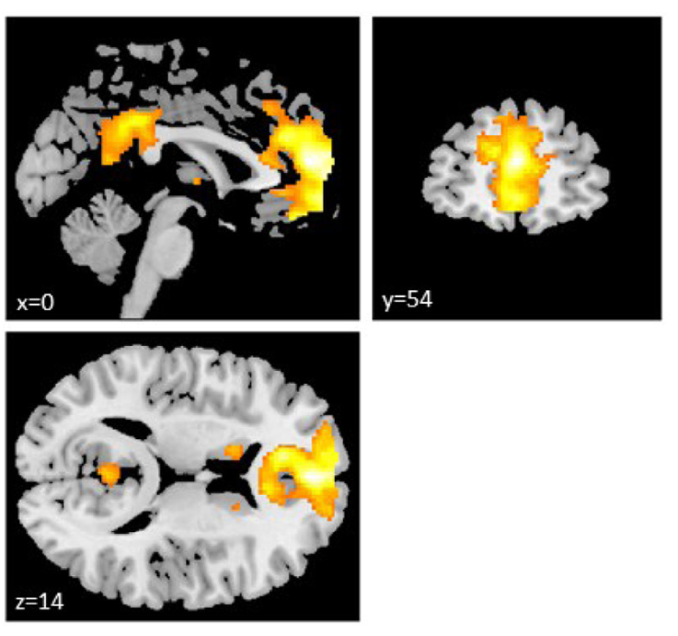

*Figure 1.* Brighter yellow colors show higher *t*-values, darker red colors indicate lower values. Only positive t-values with uncorrected *p* < 0.001 are shown. Reproduced from Figure 4A of Sellitto et al. (2021) in NeuroImage, a well known journal dedicated to neuroimaging.

**The Problem**

Figure 1 is the standard image that one might see in cognitive neuroscience textbooks and papers. A simple mass univariate *t*-contrast is done for each voxel between two conditions and only significant values are shown. There are multiple issues here that will be re-iterated in the following examples. Firstly, though the untrained viewer may know what a brain looks like, it is unclear where ‘x=0’, ‘y=54’ or ‘z=14’ are supposed to be in the brain. Furthermore, the activation patterns obscure neuroanatomical features that may clarify what part of the brain one is seeing. However, even in situations where activation patterns did not obscure anatomy, it takes far more training and focus to be able to use subtle features such as the shape of the ventricles or the gap between the occipital lobes to understand where a slice of the brain comes from. In summary, the problem is that: (1) 2D slices unnecessarily raise the bar for who can understand the image; and (2) wastes the familiar viewer’s energy by forcing them to scan irrelevant features of the image to understand where the activation is. In other words, these 2D visualizations lack ‘interocularity’ (Tukey, 1990).

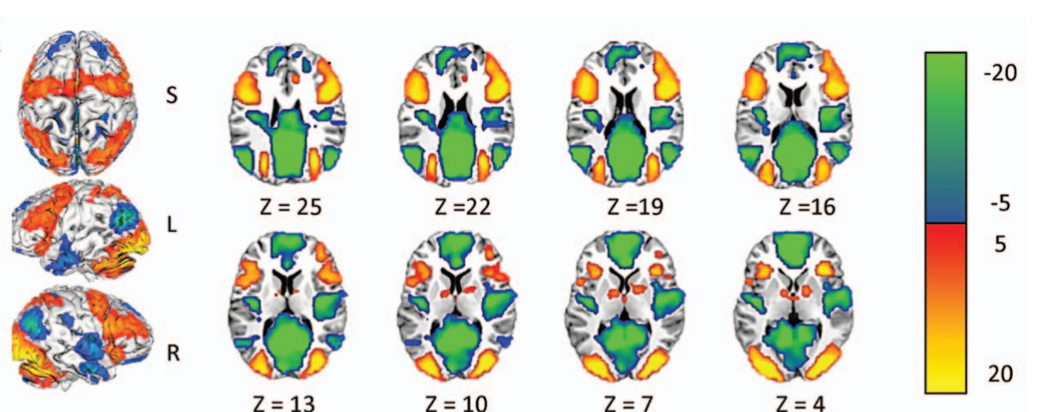

*Figure 2.* More negative and greener colors indicate higher activity during cross-fixation, as compared to performing various cognitive tasks. More positive and yellow colors indicate higher activity during the tasks, as compared to during cross-fixation. Several slices taken at varying levels of the Z-axis are shown in the middle; and multiple views of the brain’s cortex are shown on the left. ‘S’ indicates the superior view, ‘L’ indicates left and ‘R’ indicates right. Reproduced from Figure 2A of Anderson et al. (2014).

Figure 2 shares the same issues as Figure 1. Although a viewer may reasonably infer that the different Z-values indicate different slices through the Z-axis, without the Z-values the untrained viewer would not be able to tell which slices should be at the top or bottom, or if they are even in the correct order. Furthermore, the activation pattern is so large, that without careful attention, one might falsely mistake that each of the slices are the same because of how they obscure key neuroanatomical features. What is unique here that is not as evident in Figure 1, is that there is clearly a volume of brain matter that is being activated. However, having several 2D slices makes it difficult to imagine this volume and of which smaller structures are and are not being activated.

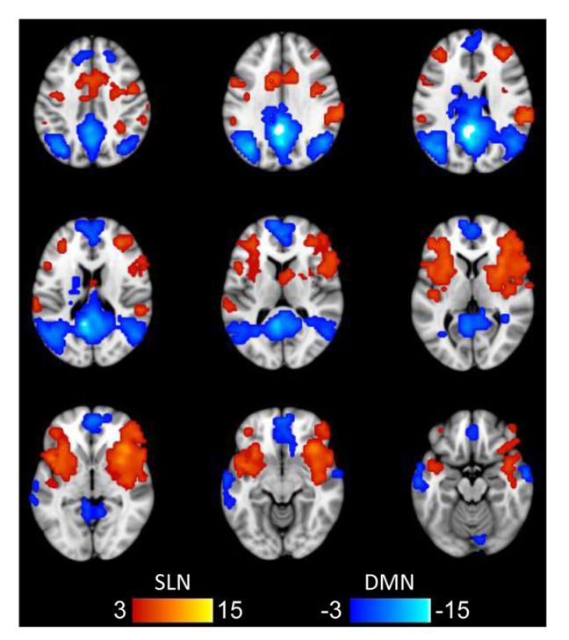

*Figure 3.* Shown here are multiple slices taken throughout the Z-axis. More negative values indicate higher resting-state functional connectivity with the posterior cingulate cortex; more positive values indicate higher resting-state functional connectivity with the anterior insula/frontal operculum. Resting-state functional connectivity is when participants are asked to lie in a scanner and stay awake as the scanner collects data on their brain activity (Grady et al., 2015). A higher absolute functional connectivity indicates a stronger correlation between two regions (Op de Beeck & Nakatani, 2019). Reproduced from Figure 1A of Grady et al. (2015).

Figure 3 repeats the same issues as in Figure 1 and 2, however there is not even a clear indication of where each slice lies on the Z-axis. Here, the activation patterns also obscure neuroanatomical features and the volume of activation is difficult to imagine.

In summary, these visualizations show that current 2D visualizations are (1) prevalent in the literature; and (2) riddled with various issues that interfere with a deeper understanding of the data. To elaborate on the difficulty in imagining the volume of activation using 2D slices, it as if we are viewing a ship in a bottle, where the bottle is nearly filled with sand. Although we may tilt the bottle at various angles to see different parts of the ship, we never see the ship in its entirety and are enslaved to mere glimmers of outer parts of the ship. Furthermore, while other scientific visualizations indicate uncertainty in their statistical estimates—and as brought up by Yarkoni and Friston’s exchange (Yarkoni, 2012)—we see no indication of variability or uncertainty in any of the above visualizations. This is understandable because the visualization is already crowded enough, but it is nonetheless a serious problem when one considers that there is no practical way to understand the stability of our estimates and the recent replication crises in science (Button et al., 2013; Collaboration, 2015; Friston, 2012; Ioannidis, 2005). Because each voxel is a separate estimate and because there are so many voxels, one cannot even use tables or in-text descriptions to meaningfully illustrate their stability—such a table would be pages upon pages long. Typically and out of convenience, this is addressed by describing each region’s ‘peak’ voxel’s values and variability—peak typically meaning the ‘strongest’ value within a contiguous cluster of significantly activated voxels (Chen et al., 2021)—but there is no theoretical reason to believe that the peak voxel alone tells the whole story behind a region’s involvement in a cognitive task (Chen et al., 2021). One example of this is shown below in Table 1.

**Table 1.** Table of peak voxel coordinates by brain region in a mass univariate *t*-contrast between two different task conditions.

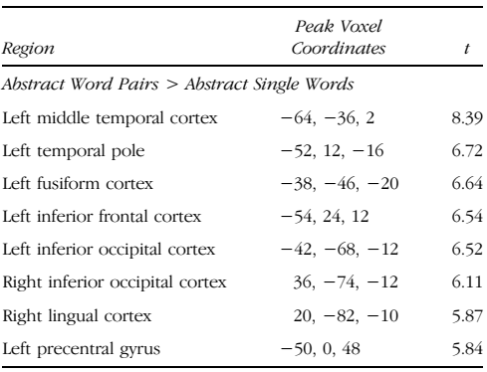

*Note.* Different brain regions are indicated in the leftmost column, the coordinates of the peak voxel of that brain region in the middle; and the associated *t*-value on the right. Reproduced from Table 7 of Clark et al. (2018).

Looking at the table, one may be struck by the specialized terminology and of how little the peak voxel coordinates inspires one’s imagination—all of this only makes it more difficult for non-specialists to understand neuroimaging papers. How can these problems be addressed by visualization?

**Proposal for Better Visualizations**

**Details and Requirements**

Upon examining the images more closely, one approach that arises is that most of the problems stem from using a 2D representation of a fundamentally 4D problem. As shown in Figures 1, 2 and 3, 2D representations only ever show two dimensions of the activation, meaning that only the area—and not the volume—of activation is ever shown at one time. Understandably, one reason why 2D approaches are favored is because a 3D view from the outside of the brain would hide much of the subcortical activation. However, if activation on the cortical surface is the only feature of interest, Gao et al. (2015) propose to inflate, then flatten the cortical surface, so that the location of activation is clearly seen—as shown in Figure 4 below.

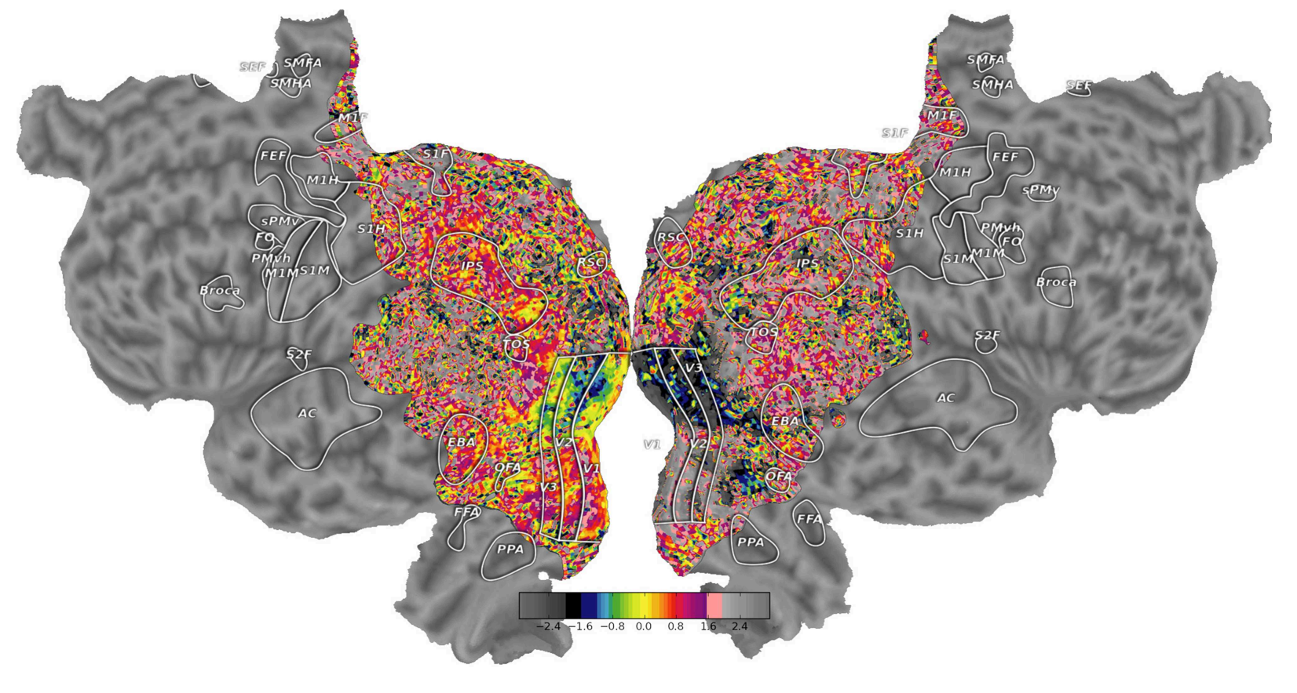

*Figure 4.* Shown here is an inflated, then flattened version of the cortex called a ‘flatmap’. Important regions are encircled and abbreviated. Reproduced from Figure 6 of Gao et al. (2015).

However, their approach may make it difficult to link the flattened depiction to the actual brain and it still does not address subcortical visualization. To address subcortical features in 3D, various software packages (such as Mowinckel & Vidal-Piñeiro, 2020; Pyka et al., 2010; *Research Imaging Institute — Mango*, n.d.) vary the cortical surface’s opacity—or transparency—in order to make subcortical features visible. Following this logic, Mango was used to create a mock-up of this idea in Figure 5.

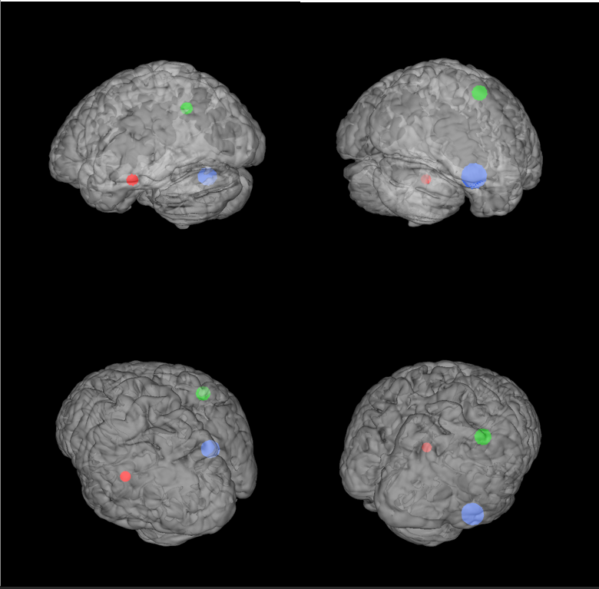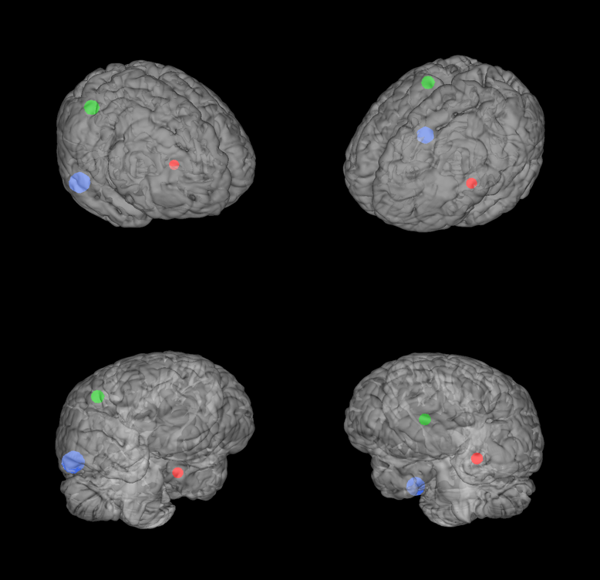

*Figure 5.* Shown here are 8 different perspectives of a transparent brain, featuring activation in various subcortical regions. If one imagines that the brain is encased in a rectangular prism, the intention is for each perspective to align with a different vertex of the prism to minimize overlap in perspective. This figure was produced using Mango (*Research Imaging Institute — Mango*, n.d.).

As one can see in Figure 5, a new issue that this approach creates is that multiple perspectives must be shown to better understand the location of each volume of activation. However, it is unknown how many and what perspectives are necessary to solve this problem. Thus, the next solution is to use 4D, meaning an animation of the brain rotating in space, which is also a commonly supported feature (Mowinckel & Vidal-Piñeiro, 2020; Pyka et al., 2010; *Research Imaging Institute — Mango*, n.d.). Once again, Mango was used to create a mock-up of this idea in Figure 6.



*Figure 6.* Shown here is an animation of a brain rotating in space as its opacity varies with time. Volumes of activations are interspersed throughout the brain. This figure was produced using Mango (*Research Imaging Institute — Mango*, n.d.).

Using 4D increases the range of possibilities dramatically. As shown in Figure 6, it allows us to vary the opacity with the rotating animation, allowing viewers to shift their attention between cortical and subcortical features. However, based on my search of the available software, there are no solutions that were intended to make use of 4D beyond recording the brain in rotation (Pyka et al., 2010). Even Mango crashed several times when I tried to manually change the opacity as it was recording the rotation and the rotation speed cannot be adjusted. Another problem that 4D solves is the illustration of uncertainty, as shown in Figure 7.

 

*Figure 7.* Shown here is a representation of the stability of an estimate through the range of colors it animates. The left figure is a representation of a stable estimate, its color changes slightly. The right figure is an unstable estimate, its color changes rapidly during the same time that the left figure cycles through its colors. This figure was made using ggplot2, ggAnimate and colorspace in R (Pedersen et al., 2020; R Core Team, 2021; Wickham et al., 2021, p. 2; Zeileis et al., 2020).

As shown above, by varying the range of colors that a voxel animates, the uncertainty is easily displayed. More uncertain or unstable estimates have a far larger range of colors, so their change is highly evident, whereas more stable estimates only change slightly. At the time of writing, there does not appear to be a neuroimaging software that can fulfill this idea. Another possibility enabled by 4D is to ‘explode’ the voxels, just as in an exploded diagram (Li et al., 2004)—as shown in Figure 8. Given the complexity of the proposed animation, no mock-up could be created at this time.

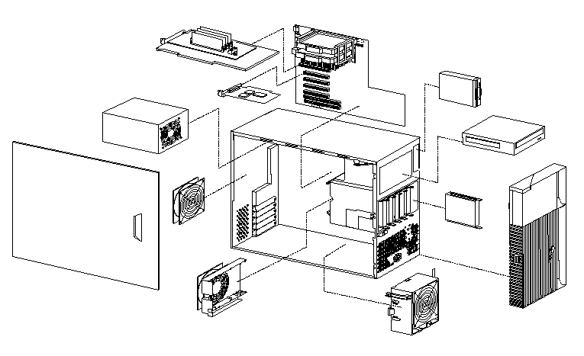

*Figure 8.* Shown here is an exploded image of an IBM IntelliStation Z Pro (Type 6866) (*Computer Exploded View - IBM IntelliStation Z Pro (Type 6866)*, 2001). The image attempts to show where different parts of the computer belong and how it can be assembled.

One way that exploded diagrams could be used is to separate voxels based on their similarity and by their degree of activation. For example, highly activated and less uncertain voxels could cluster closer together, whereas less activated and more uncertain voxels could be exploded farther apart. To keep a semblance of being in the brain, there could be a translucent outline of key neuroanatomical features in the background, so that the location of these highly stable and activated voxels is better seen.

Many more ideas can be thought of to make best use of 4D, especially by making it interactive, so that viewers may freely control which part of the brain to focus on or to disable animations they find distracting. However, one concern is that these animations could never make it to a journal article. Although many papers sidestep this issue by including URLs, URLs lack the permanency that a pdf has. To solve this problem and achieve interactivity, I propose the use of a Quick Response (QR) code-like technology to embed the data and key features of the animation within the pdf. Then, the visualization could be reconstructed later in an R Shiny application (Chang et al., 2021). A diagram of this ideal workflow is shown in Figure 9.

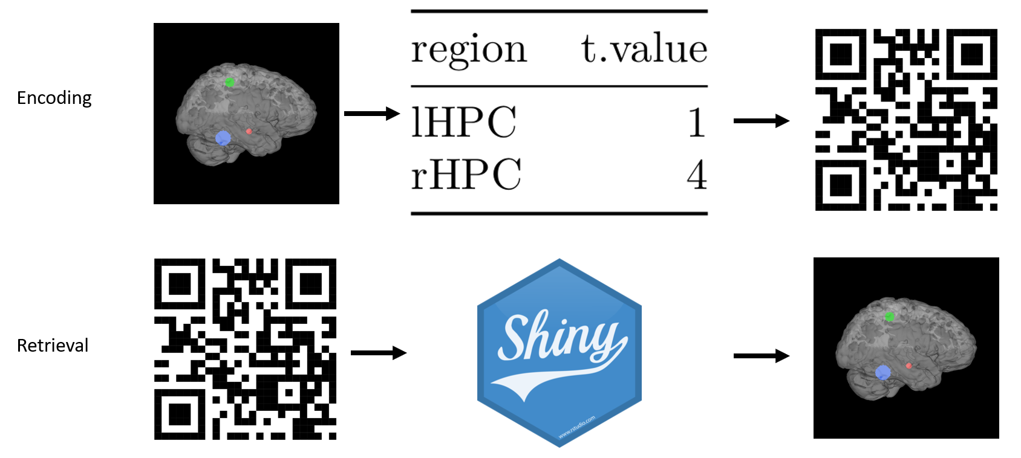

*Figure 9.* The user should be able to transform their visualization into a data frame, which is then turned into a QR code. Then, a viewer can scan the QR code to re-obtain the data frame, which can then recreate the visualization in a R shiny application. Brain visualization was created using Mango (*Research Imaging Institute — Mango*, n.d.), the table using R Markdown (Allaire et al., 2021; Xie et al., 2018, 2020); the QR code from the R qrcode package (Teh, 2015); and the R Shiny logo came from R Studio’s GitHub (*Rstudio/Hex-Stickers*, 2018/2021).

However, one issue with this approach is that QR codes may not be able to encode the quantity of information typically found in fMRI. As suggested by Victor (2012), this may be alleviated by compressing the data before encoding it into a QR code, but it is unclear if compression will suffice for this scale of data. If insufficiency is the case, then one alternative may be for the QR code to contain URLs to several locations where the data is stored and for where the visualization software is hosted. For example, the QR code might link to an Open Science Framework (OSF) URL that contains the data and with the author’s webserver where they host the R Shiny application that can recreate the software. In case the author’s webserver no longer functions, then the R Shiny application may be downloaded from the Comprehensive R Archive Network (CRAN) directly and run from the viewer’s computer. Nevertheless, ideally a QR code-like technology would be used to contain the visualization data itself; this approach would reduce the dependency of reproducibility on other software and platforms.

Another benefit of a QR-code like technology is that it would affect the way scientific discussion are held. By scanning the QR code during a presentation, audience members would be able to directly interact with the visualization on their mobile devices, which would improve their understanding and ability to discuss the findings. Although one concern is that this distracts the audience from the presenter, cognitive neuroscience is special in that investigators tend to be specialized in only certain parts of the brain. This means that traditionally, it is difficult for a presenter to make the findings directly relevant to all audience members, however putting the interactive data in their hands could change this. To illustrate this further, imagine that you are at a conference followed by a break, then dinner. During the conference, you would be able to scan the QR code, then understand the data during your break. During dinner, you would be able to ask nuanced questions regarding findings, instead of having to go off of your memory or notes. That is the future that QR-code like technologies may give to the scientific community and that may already be achieved through R Shiny.

**Empirical Verification**

There are a variety of concerns here that would profit from experimental investigation. For example, what is the best combination of perspectives of a complex 3D translucent object, such as the brain, to maximize our understanding of the data visualization? Does the idea of varying opacity during an animated rotation of a complex 3D object, as described above, actually improve our understanding or is it just fanciful speculation? Because both concerns can be side-stepped through interactivity, I will instead propose an experiment that directly touches upon the main goal of my proposal. Specifically, are the purported advantages of taking a 3D/4D approach over the common 2D approach to visualizing brain activity enough to outweigh 3D’s associated flaws (Elliott, 2019)? What does a 3D/4D visualization hide, in comparison with a 2D approach? I propose that the most direct answer is to compare the identification accuracy, speed and memory of 3D/4D versus 2D visualizations in students taking a course in neuroanatomy.

In total, there would be 4 conditions: 8 different perspectives of a 3D visualization; 8 different 2D slices of the brain activation; a non-interactive animation; and lastly, an interactive animation. Although our cited examples use less than 8 2D visualizations on average, having 8 2D slices minimizes the unimportant differences with the 8 perspectives of the 3D visualization. Secondly, because the interactive animation may encourage longer viewing times than other visualizations, I also propose to limit each trial to one minute for both studying the visualization and identifying its affected regions. To not overtire the participants while maintaining statistical power, I propose for there to be 32 randomized trials made up of 8 different examples of each of the 4 conditions, which would take about 32 minutes. After every 8 visualizations, participants will be asked to recall the affected areas in each of the most recent set of trials—meaning the last 8 visualizations—to test for how the type of visualization may affect their memory of the activation patterns. Then, at the end of all trials, participants will be asked to recall as many affected regions from all the previously presented visualizations as possible. Although multiple recalls is known to affect memory of the visualizations (Karpicke & Roediger, 2008), that effect should not matter here because, naturalistically, visualizations will be thought of—and hence recalled—multiple times, if it is of interest to them.

Lastly, following the experimental task, I propose to conduct a post-experimental interview participant on their self-reported experience of using each of the different kinds of visualizations. After all, it could be the case that although performance with interactive animations is objectively superior to 2D images, if the subjective experience is so poor, then widespread adoption is unlikely. Although introspection—meaning self-report (Young, 2013)—is traditionally thought to be of little use (Costall, 2013), partly because it is tainted by memory’s nature (Brock, 2013), this may be a rare scenario where their memory is key to answering our question. Building off of Redelmeier & Kahneman (1996), I expect the memory of how satisfied a participant is when using the visualization to be more important towards their adoption of the technology than the ongoing experience. Therefore, the post-experimental interview should still be valid, as opposed to live commentary while the participants use the visualization.

Thus, through the empirical comparison of participants’ identification ability between the different visualization conditions, we obtain an objective indication of whether 3D/4D approaches are superior to 2D in this aspect. Furthermore, the post-experimental interview should provide insight on their enjoyment of the visualization, which will likely affect adoption. However, future investigations should focus on what drawbacks 3D/4D visualizations have in comparison with a 2D approach. One speculation is that an active animation may be distracting, or even hypnotizing, to the audience during live presentations. This may be addressed by only moving the brain when it makes the presenter’s point more easily understood or to direct the audience’s attention.

**Conclusion**

Here, I have (1) discussed the current problems affecting fMRI visualization in both guiding analysis and disseminating findings; (2) proposed a 3D/4D solution to the problem, while suggesting various innovations; and (3) discussed an empirical comparison of my proposal to traditional visualizations. Data visualizations can help conceive profound insights, but it can also be used to deceive. As aforementioned, many problems plague fMRI studies, but these problems create the incentive to find elegant solutions that otherwise might not have come into existence. This proposal has focused on a very specific aspect of fMRI investigations, contrasts in simple scenarios. However, it tries to thoroughly address all aspects of this aspect, so that a wider audience may appreciate this type of study’s findings and to improve scientific reasoning—to understand what it all means. Though recent discussions regarding improving fMRI analysis have focused on statistical techniques (Chen et al., 2021); logical inferences (Kriegeskorte et al., 2009; Poldrack, 2006); and computational reproducibility (Botvinik-Nezer et al., 2020; Poldrack et al., 2017): it is hoped that the importance of visualizing our findings (Gordon & Finch, 2015) will not be lost in the discussion.

**References**

Allaire, J. J., Xie, Y., McPherson, J., Luraschi, J., Ushey, K., Atkins, A., Wickham, H., Cheng, J., Chang, W., & Iannone, R. (2021). *rmarkdown: Dynamic Documents for R*. https://github.com/rstudio/rmarkdown

Anderson, J. A. E., Campbell, K. L., Amer, T., Grady, C. L., & Hasher, L. (2014). Timing is everything: Age differences in the cognitive control network are modulated by time of day. *Psychology and Aging*, *29*(3), 648–657. https://doi.org/10.1037/a0037243

Botvinik-Nezer, R., Holzmeister, F., Camerer, C. F., Dreber, A., Huber, J., Johannesson, M., Kirchler, M., Iwanir, R., Mumford, J. A., Adcock, R. A., Avesani, P., Baczkowski, B. M., Bajracharya, A., Bakst, L., Ball, S., Barilari, M., Bault, N., Beaton, D., Beitner, J., … Schonberg, T. (2020). Variability in the analysis of a single neuroimaging dataset by many teams. *Nature*, *582*(7810), 84–88. https://doi.org/10.1038/s41586-020-2314-9

Brock, A. C. (2013). The history of introspection revisited. *Self-Observation in the Social Sciences*, 25–43.

Button, K. S., Ioannidis, J. P. A., Mokrysz, C., Nosek, B. A., Flint, J., Robinson, E. S. J., & Munafò, M. R. (2013). Power failure: Why small sample size undermines the reliability of neuroscience. *Nature Reviews Neuroscience*, *14*(5), 365–376. https://doi.org/10.1038/nrn3475

Chang, W., Cheng, J., Allaire, J. J., Sievert, C., Schloerke, B., Xie, Y., Allen, J., McPherson, J., Dipert, A., Borges, B., RStudio, library), jQuery F. (jQuery library and jQuery U., inst/www/shared/jquery-AUTHORS.txt), jQuery contributors (jQuery library; authors listed in, inst/www/shared/jqueryui/AUTHORS.txt), jQuery U. contributors (jQuery U. library; authors listed in, library), M. O. (Bootstrap, library), J. T. (Bootstrap, library), B. contributors (Bootstrap, Twitter, library), I. (Bootstrap, … R), R. C. T. (tar implementation from. (2021). *shiny: Web Application Framework for R* (1.6.0) [Computer software]. https://CRAN.R-project.org/package=shiny

Chen, G., Taylor, P. A., Stoddard, J., Cox, R. W., Bandettini, P. A., & Pessoa, L. (2021). Dichotomous thinking and informational waste in neuroimaging. *BioRxiv*, 2021.05.09.443246. https://doi.org/10.1101/2021.05.09.443246

Clark, I. A., Kim, M., & Maguire, E. A. (2018). Verbal Paired Associates and the Hippocampus: The Role of Scenes. *Journal of Cognitive Neuroscience*, *30*(12), 1821–1845. https://doi.org/10.1162/jocn_a_01315

Collaboration, O. S. (2015). Estimating the reproducibility of psychological science. *Science*, *349*(6251). https://doi.org/10.1126/science.aac4716

*Computer exploded view—IBM IntelliStation Z Pro (Type 6866)*. (2001, December 20). [CT741]. https://www.ibm.com/support/pages/computer-exploded-view-ibm-intellistation-z-pro-type-6866

Costall, A. (2013). Introspection and the myth of methodological behaviorism. *Self Observation in the Social Sciences*, 67–80.

Danziger, K. (2008). *Marking the mind: A history of memory*. Cambridge University Press.

Eklund, A., Nichols, T. E., & Knutsson, H. (2016). Cluster failure: Why fMRI inferences for spatial extent have inflated false-positive rates. *Proceedings of the National Academy of Sciences*, *113*(28), 7900–7905. https://doi.org/10.1073/pnas.1602413113

Elliott, K. (2019, October 22). *39 studies about human perception in 30 minutes*. Medium. https://medium.com/@kennelliott/39-studies-about-human-perception-in-30-minutes-4728f9e31a73

Friston, K. (2012). Ten ironic rules for non-statistical reviewers. *NeuroImage*, *61*(4), 1300–1310. https://doi.org/10.1016/j.neuroimage.2012.04.018

Gao, J. S., Huth, A. G., Lescroart, M. D., & Gallant, J. L. (2015). Pycortex: An interactive surface visualizer for fMRI. *Frontiers in Neuroinformatics*, *9*. https://doi.org/10.3389/fninf.2015.00023

Gordon, I., & Finch, S. (2015). Statistician Heal Thyself: Have We Lost the Plot? *Journal of Computational and Graphical Statistics*, *24*(4), 1210–1229. https://doi.org/10.1080/10618600.2014.989324

Grady, C. L., Luk, G., Craik, F. I. M., & Bialystok, E. (2015). Brain Network Activity in Monolingual and Bilingual Older Adults. *Neuropsychologia*, *66*, 170–181. https://doi.org/10.1016/j.neuropsychologia.2014.10.042

Ioannidis, J. P. A. (2005). Why Most Published Research Findings Are False. *PLoS Medicine*, *2*(8). https://doi.org/10.1371/journal.pmed.0020124

Karpicke, J. D., & Roediger, H. L. (2008). The Critical Importance of Retrieval for Learning. *Science*, *319*(5865), 966–968. https://doi.org/10.1126/science.1152408

Kriegeskorte, N., Simmons, W. K., Bellgowan, P. S., & Baker, C. I. (2009). Circular analysis in systems neuroscience – the dangers of double dipping. *Nature Neuroscience*, *12*(5), 535–540. https://doi.org/10.1038/nn.2303

Li, W., Agrawala, M., & Salesin, D. (2004). Interactive image-based exploded view diagrams. *Proceedings of Graphics Interface 2004*, 203–212.

McCabe, D. P., & Castel, A. D. (2008). Seeing is believing: The effect of brain images on judgments of scientific reasoning. *Cognition*, *107*(1), 343–352. https://doi.org/10.1016/j.cognition.2007.07.017

Mowinckel, A. M., & Vidal-Piñeiro, D. (2020). Visualization of Brain Statistics With R Packages ggseg and ggseg3d. *Advances in Methods and Practices in Psychological Science*, *3*(4), 466–483. https://doi.org/10.1177/2515245920928009

Op de Beeck, H., & Nakatani, C. (2019). *Introduction to Human Neuroimaging*. Cambridge University Press. https://doi.org/10.1017/9781316847916

Pedersen, T. L., Robinson, D., & RStudio. (2020). *gganimate: A Grammar of Animated Graphics* (1.0.7) [Computer software]. https://CRAN.R-project.org/package=gganimate

Poldrack, R. A. (2006). Can cognitive processes be inferred from neuroimaging data? *Trends in Cognitive Sciences*, *10*(2), 59–63. https://doi.org/10.1016/j.tics.2005.12.004

Poldrack, R. A., Baker, C. I., Durnez, J., Gorgolewski, K. J., Matthews, P. M., Munafò, M. R., Nichols, T. E., Poline, J.-B., Vul, E., & Yarkoni, T. (2017). Scanning the horizon: Towards transparent and reproducible neuroimaging research. *Nature Reviews. Neuroscience*, *18*(2), 115–126. https://doi.org/10.1038/nrn.2016.167

Poldrack, R. A., Mumford, J. A., & Nichols, T. E. (2011). *Handbook of functional MRI data analysis*. Cambridge University Press.

Pyka, M., Hertog, M., Fernandez, R., Hauke, S., Heider, D., Dannlowski, U., & Konrad, C. (2010). FMRI Data Visualization with BrainBlend and Blender. *Neuroinformatics*, *8*(1), 21–31. https://doi.org/10.1007/s12021-009-9060-3

R Core Team. (2021). *R: A Language and Environment for Statistical Computing*. R Foundation for Statistical Computing. https://www.R-project.org/

Racine, E., Bar-Ilan, O., & Illes, J. (2005). FMRI in the public eye. *Nature Reviews Neuroscience*, *6*(2), 159–164. https://doi.org/10.1038/nrn1609

Redelmeier, D. A., & Kahneman, D. (1996). Patients’ memories of painful medical treatments: Real-time and retrospective evaluations of two minimally invasive procedures. *Pain*, *66*(1), 3–8. https://doi.org/10.1016/0304-3959(96)02994-6

*Research Imaging Institute—Mango*. (n.d.). Retrieved June 25, 2021, from http://ric.uthscsa.edu/mango/

*Rstudio/hex-stickers*. (2021). [R]. RStudio. https://github.com/rstudio/hex-stickers (Original work published 2018)

Sellitto, M., Neufang, S., Schweda, A., Weber, B., & Kalenscher, T. (2021). Arbitration between insula and temporoparietal junction subserves framing-induced boosts in generosity during social discounting. *NeuroImage*, *238*, 118211. https://doi.org/10.1016/j.neuroimage.2021.118211

Teh, V. (2015). *qrcode: QRcode Generator for R* (0.1.1) [Computer software]. https://CRAN.R-project.org/package=qrcode

Tukey, J. W. (1990). Data-Based Graphics: Visual Display in the Decades to Come. *Statistical Science*, *5*(3), 327–339.

Victor, N. (2012). Enhancing the data capacity of qr codes by compressing the data before generation. *International Journal of Computer Applications*, *60*(2), 0975–8887.

Wickham, H., Chang, W., Henry, L., Pedersen, T. L., Takahashi, K., Wilke, C., Woo, K., Yutani, H., Dunnington, D., & RStudio. (2021). *ggplot2: Create Elegant Data Visualisations Using the Grammar of Graphics* (3.3.5) [Computer software]. https://CRAN.R-project.org/package=ggplot2

Xie, Y., Allaire, J. J., & Grolemund, G. (2018). *R Markdown: The Definitive Guide*. Chapman and Hall/CRC. https://bookdown.org/yihui/rmarkdown

Xie, Y., Dervieux, C., & Riederer, E. (2020). *R Markdown Cookbook*. Chapman and Hall/CRC. https://bookdown.org/yihui/rmarkdown-cookbook

Yarkoni, T. (2012, April 25). A very classy reply from Karl Friston. *[Citation Needed]*. https://www.talyarkoni.org/blog/2012/04/25/a-very-classy-reply-from-karl-friston/

Young, J. L. (2013). A brief history of self-report in American psychology. *Self-Observation in the Social Sciences*, 45–65.

Zeileis, A., Fisher, J. C., Hornik, K., Ihaka, R., McWhite, C. D., Murrell, P., Stauffer, R., & Wilke, C. O. (2020). colorspace: A Toolbox for Manipulating and Assessing Colors and Palettes. *Journal of Statistical Software*, *96*(1), 1–49. https://doi.org/10.18637/jss.v096.i01